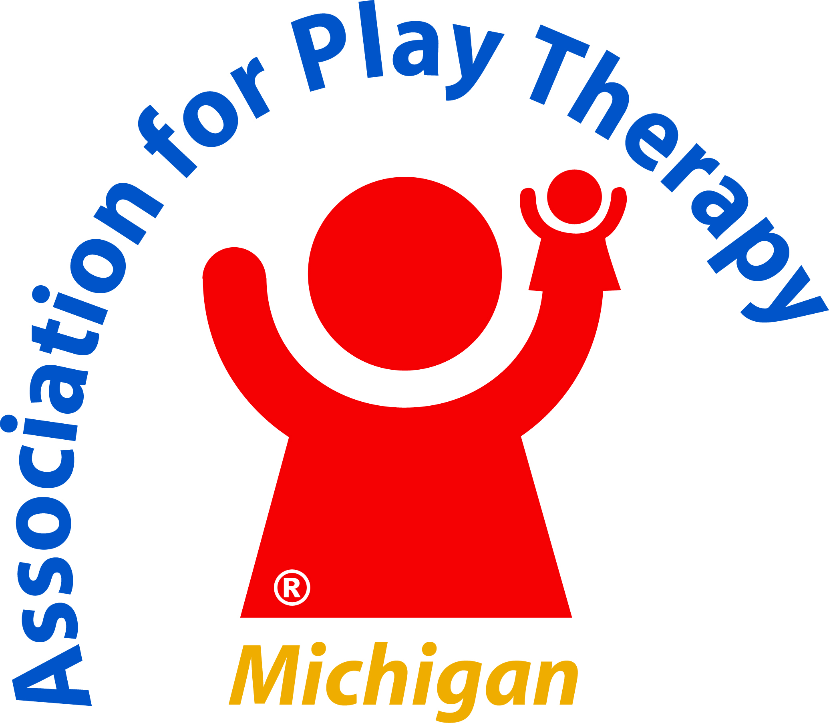

Prospective Conference Sponsor,

2020-2021 BOARD OF DIRECTORS

Jason Clanton
President
Laura Hutchison
President-Elect
Gayla Ignacio
Secretary
Ann Bixler
Treasurer
Shana Bombrys
Past President

Christina Collins
Director-at-Large
Sabrina Slagter
Director-at-Large

CONTACT INFORMATION

info@miapt.org
Address
MIAPT
2020 E. Raybrook Avenue, SE
Suite 305
Grand Rapids, MI 49546

Website
www.MIAPT.org

Conference Chair
Abigail DuPree

The Michigan Association for Play Therapy (MIAPT) invites your participation in promoting your business by sponsoring MIAPT’s 25th Annual Conference, February 17-20, 2021, which will be held virtually.

We are planning ten (10) different sessions among four (4) days with plenty of opportunity for participants to engage. Since this is our first virtual conference, we are excited about the potential to triple our regular number of attendees, which will provide your business with professional exposure to more participants from the entire state of Michigan as well as surrounding states. Our sponsorship levels are listed below.

We hope you will take advantage of this great marketing opportunity. Please contact us at your earliest convenience so we can be sure to include you in the conference promotional materials and on the website to give you maximum exposure.

Once sponsorship is secured, all questions will be managed by Thom Vincent, Program Coordinator, at 602-918-5505 or mymiapt@gmail.com. We look forward to welcoming you as a sponsor for the 2021 Annual Conference!

Sincerely,
Jason

Jason Clanton, MA, LLP, Registered Play Therapist™
MIAPT President

Michigan Association for Play Therapy

Who We Are
Established in 1996, the Michigan Association for Play Therapy (MIAPT) is a state branch of the Association for Play Therapy, Inc.

MIAPT seeks to:
- educate mental health providers, insurance suppliers, physicians, attorneys, judges and the public about play therapy and that play therapy is often the most viable treatment option for children and adolescents;
- engage mental health practitioners in extensive play therapy training and supervision;
- provide our child clients and their families with the best evidence-based and practice-based evidence for assessment and treatment interventions to promote healing and health; and
- advocate for the rights of children, their families and significant others.
Why Play Therapy?
For children, play is recognized as one of the most natural modes of learning and interacting with others. It is through play that children often express their feelings, explore themselves and their relationships, and attempt to understand their experiences. Children may be able to transfer their anxieties, fears, and guilt through toys. Through play therapy, children may be able to increase their feelings of self-worth and self-acceptance with the help of a caring relationship with an adult. Children are encouraged to understand their play as a way to express, explore, and work through conflicts and issues. Play therapy also promotes the exploration of feelings and behaviors associated with past events and issues outside of the playroom.

Our Programs
MIAPT prides itself in offering educational opportunities to our members and to professionals in the community.
- Regional Workshops with Hands-on Training
- Networking Opportunities
- Annual State Conference with Nationally and Internationally Recognized Experts
- Volunteer Opportunities & Leadership Development
- Scholarship Opportunities
- Community Resources and Outreach
- Bi-Monthly Newsletters and News Flash

Our Mission
The Mission of MIAPT is to unite all persons interested in the therapeutic process of play therapy and advance the principles and ethical practice of play therapy among its members.

Our Key 2020-2021 Strategies
- Increase quality and availability of play therapy professional development within the State of Michigan.
- Increase public and professional awareness of the therapeutic value of play therapy.
- Continue to develop collaborative efforts with other professional organizations, universities and colleges in Michigan to promote play therapy and advocate for children and families.
- Give back through community service and volunteer opportunities.
- Develop leadership within MIAPT.
Michigan Association for Play Therapy
2021 Annual Conference
February 17-20, 2021
SPONSOR AGREEMENT

We will need your company’s logo for promotional materials. Please e-mail your logo (TIF, JPG) to: info@miapt.org by 01/10/21.

CANCELLATION POLICY: No refunds will be given. If you are unable to participate, your payment will be considered a donation to MIAPT.

PAYMENT INFORMATION: If paying by credit card, see Page 4. If paying by check, please complete and mail this form to: Ann Bixler, MIAPT, 2020 Raybrook Avenue, S.E., Suite 305, Grand Rapids, MI 49546. Confirmations will be sent via e-mail.

For additional information, please contact Thom Vincent, 602-918-5505, mymiapt@gmail.com

AGREEMENT ACCEPTANCE & GENERAL INFORMATION:
Company Name: ___________________________________________________________________________

Address: _________________________________________________________________________________

City, State & Zip___________________________________________________________________________

Telephone: (____) ____________FAX: (____)___________________E-Mail: ___________________________

Contact Name: ____________________________________________________________________________

BUSINESS DESCRIPTION FOR SPONSOR POWERPOINT SLIDE – 100 Words or Less
_____________________________________________________________________________________________________________________________________________________________________________________________________________________________________________________________________________________________________________________________________________________________________________________________________________________________________________________________
_________________________________________________________________________________________

Please provide final artwork and description for Facebook and Instagram posts.
Forward JPG or PNG files, hashtags, and description in Word for use on our social media channels to mymiapt@gmail.com.

MIAPT is a 501c3 nonprofit corporation, ID#38 3271419. Consult your tax advisor for potential tax deductions.
As a sponsor of this exciting virtual conference, the following recognition
opportunities are available: (Please circle)

Sponsor Benefits | Title Sponsor  $625 | Presenting Sponsor  $375 | Supporting Sponsor  $200
3 Minute Presentation About Your Company (choice of available day and session) | X
Introduction of one of the 2021 Conference Presenters (10 total opportunities available) | X
3 Complimentary Conference Registrations (three registrations for one session, or one registration each for three sessions), or a sponsored conference scholarship for $150 in your company’s name) | X
1 Minute Presentation About Your Company (choice of available day and session) |  | X
Sponsor slide on rolling PowerPoint during the conference; company logo and web link on our website; sponsor recognition on email blasts promoting conference (logo); sponsor thank you(s) on Facebook and Instagram (leading up to conference) | X | X | X
Social Media Posts (artwork and verbiage provided by company) on Facebook and Instagram | X | X
2 Complimentary Registrations (two registrations for one session, or one registration each for two sessions) |  | X
1 Complimentary Registration (one registration for one session) |  |  | X

PAYMENT INFORMATION (Complete the information below and return the form via mail. You may also register online at www.MIAPT.org)

Amount enclosed $_______ Check #______ Credit Card Type: MC VISA AMEX

Credit Card # ______________________________________________________Exp __________________

Name on Card: _______________________________________________________ Security Code: ______

Mailing Address: __________________________________________________________________________

Signature: _______________________________________________________________________________

Thank you for your support through sponsorship. The success of the MIAPT conference depends on supporters who are willing to make a difference. We also invite you to donate an item(s) for our drawings, which will be held throughout the conference. Your involvement, at any level, is appreciated by our Board and assists us in continuing to present quality presenters and educational programs to our members and to the community.
DONATION FORM
MIAPT Annual State Conference – February 17-20, 2021

Donor’s Name_____________________________________________________________________
Company Name/Title_______________________________________________________________
Address__________________________________________________________________________
City ___________________________________________State _____ Zip_____________________
Telephone _________________________________ Fax: __________________________________
Email ________________________________________www_______________________________

YOUR DONATION OF PRIZES FOR THE CONFERENCE DRAWING WILL ALSO PROVIDE YOU WITH RECOGNITION ON OUR POWERPOINT DURING THE CONFERENCE.

DESCRIPTION OF ITEM DONATED:
_________________________________________________________________________________
_________________________________________________________________________________
_________________________________________________________________________________
VALUE OF THE ITEM DONATED: $ _______________

RESTRICTIONS TO ITEM:
Expiration date: __________________________________

Other: _________________________________________________________________

We ask that tangible item(s) be drop-shipped from your company to the winner(s). If the items can be delivered via e-certificate or coupon code to the winner(s), that is the preferred method. If the item is a gift card, then please mail the donation to the MIAPT office.

Please email completed form to: mymiapt@gmail.com
Please mail donations to: MIAPT, c/o Ann Bixler, 2020 Raybrook Avenue, S.E., Suite 305, Grand Rapids, MI 49546
QUESTIONS? Contact Thom Vincent, 602-918-5505, mymiapt@gmail.com
MIAPT is a 501(c)3 nonprofit organization, ID #38 3271419. Donations may be eligible as a tax deduction. Please consult your tax advisor.
❐ MIAPT may contact me next year about participating in the conference drawing with a donation.

